Weekly meeting reports

Date: Oct 6 2022

Time: 10:00

Who showed up: Luca deVerteuil, Hong, stanley

## Expectations:

Expectations of this meeting is to get a better understanding of the project, pitch our ideas and get required documentation from the client

### Goal of meeting:

1. Present what Functions we will be using for this project
2. Ask for more explanation on the project:
   1. Web application for classification task that presents classified and to be classified images.
      1. Can upload or have the path
      2. Have admin and other login feature
   2. Active learning algorithm implementation, following the principles of clean code.
   3. Source code integrated in a private source code management system (e.g. GitHub, Gitlab). Including configuration and installation documentation.
   4. Data storage system for vectors (codes) that are used by the active learning algorithm and a storage system for the images.
      1. Does Not have to be connected to the server
   5. Workflow that encodes the images from a given generated water pipeline inspection and stores the codes and images.
      1. vgg16? Linked list
   6. Performance tests for the time needed for one step of the active learning process.
   7. Software architecture and technical documentation.
   8. Enhanced water pipeline inspection generator (optional).
      1. Can add as script and we can add more to the pipeline
   9. Classification performance for self-defined classification tasks (optional).
3. Ask client for signature for IP agreement
4. Ask client for blender assets

### Technical expectations:

### 

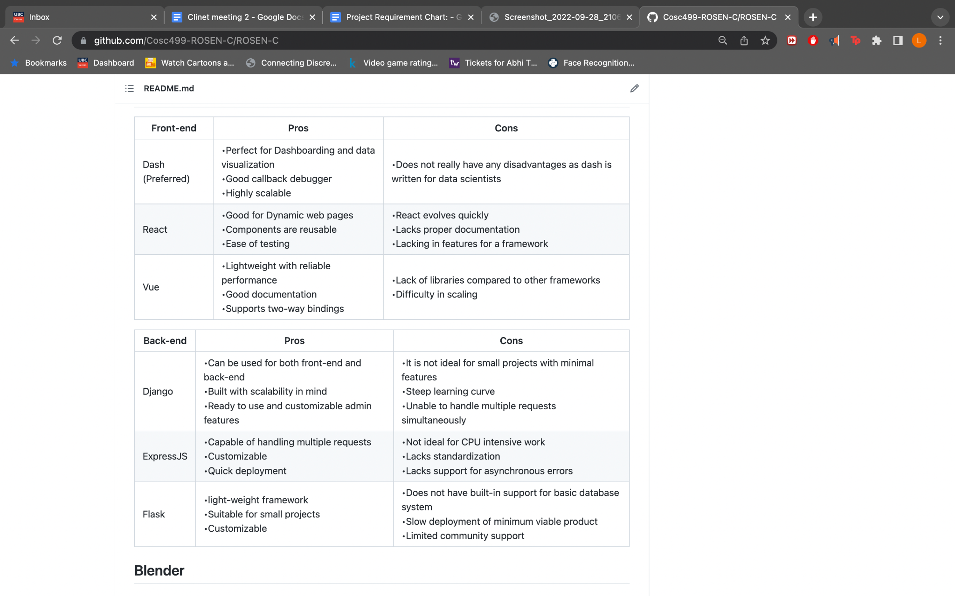

AI machine learning program : Open CV

### Other Notes:

**Do research on these topics:**

What is They use flakes?

What is And black?

What is Flake 8?

What is vvg 16?